WiserWits
Screen Walkthrough & Review Notes
Our goal through this app is to create a story/journey that parents can track and see the progress in real time. Like they can see if their child is improving or not, how his health is progressing or how BMI is changing, how academic performance is changing over time, and are getting closer to their financial goals? so the goal of the app should be to enable parents with better decision making and this can only be done if they know how things were before and how they are now and they are well aware of ‘what’ changed and ‘why’. What part of the change we have to answer through this app and why part should be answered through consultation. Your focus should be on creating a story through numbers and our consultants would answer the why part and put the numbers into qualitative aspect

Home Taskbar
Screen 1 Home
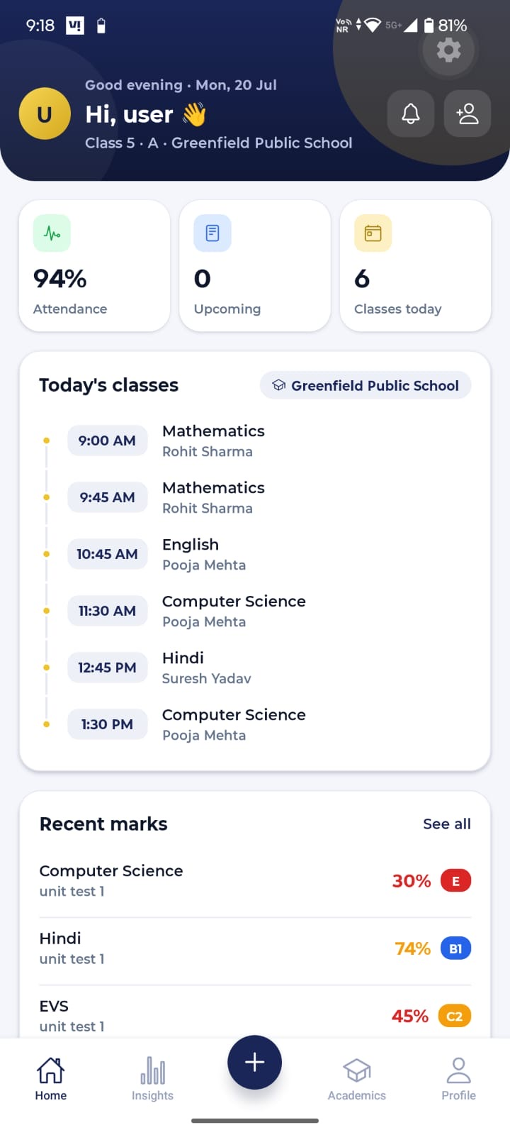 | Notes  1. Replace the classes today from the top with holistic parameters summary - DONE  2. Show the “Today’s Classes” Section for students till 8th and post that show detailed holistic summary - DONE  3. Include upcoming webinar or seminars in the upcoming section, health checkup  4. Home page is heavily focused on Academics, but it should include health and financial parameters as well (it should include key parameters from all 3 and should summarize what the user would see in the other 3 sections)  5. Provide quick links to upcoming Yoga and meditation sessions, upcoming quizzes on the home page, upcoming health checkups etc.  6. Insights can be shown on the home page and keep 3 separate sections for Academics, Health and Finance. Show all the details like recent marks and Today’s classes on the academic's section (keep the home page summaries and quick links and important parameters) - courses section can be kept under the academics, but it should be easily distinguishable  7. Move the ‘Profile’ section from the bottom to the user icon or image in the top left corner - DONE  8. Show average YTD attendance - DONE  9. Our consultant would connect with Parents/Students regularly at fixed intervals (weekly, fortnightly, monthly), can you prepare a small section on the home page for like upcoming meeting time, date and agenda, basic details about the consultant like name and phone number  10. Plan the application for students who are not affiliated with us through a school (how the academics sections would look like for them as their parents would have to upload report cards etc.). some sections like recent marks, upcoming exams might not be valid for them and new sections like who the contributor is and add contributor would be needed

Screen 2 Home
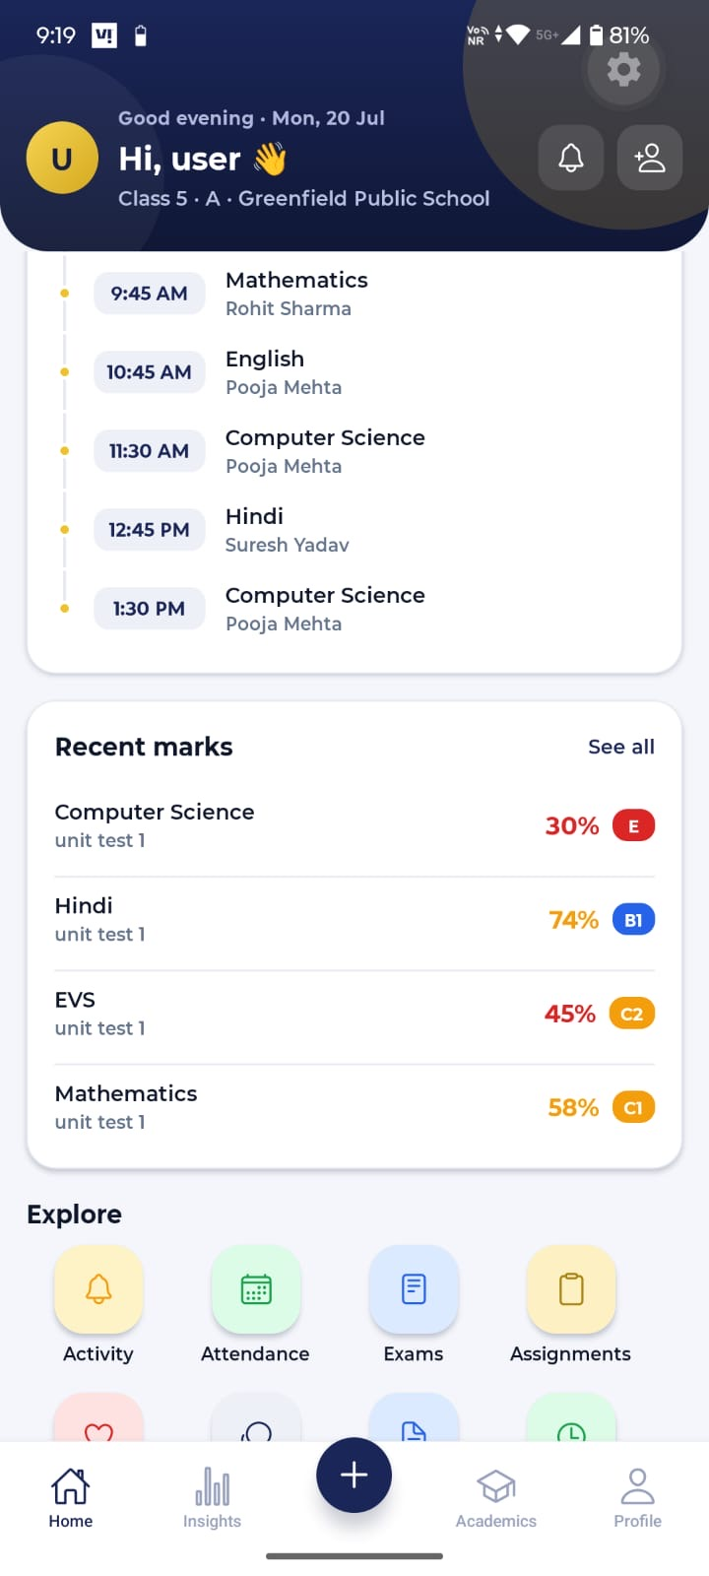 | Notes  11. Can we keep some sections like today’s classes time sensitive – these sections are visible on the top if someone is viewing the app in morning but it’s not visible during the day and if someone is viewing the app at night then it should show tomorrow’s classes  - DONE ( today’s timetable shows till the last period ends and then the card will shows tomorrow timetable , also i have added holistic card for students in and above 5th class.)  12. Grades should only be shown if they are added by school, if school is not using the grade system, then we should not show grades (show percentage only) - DONE

Screen 3 Home
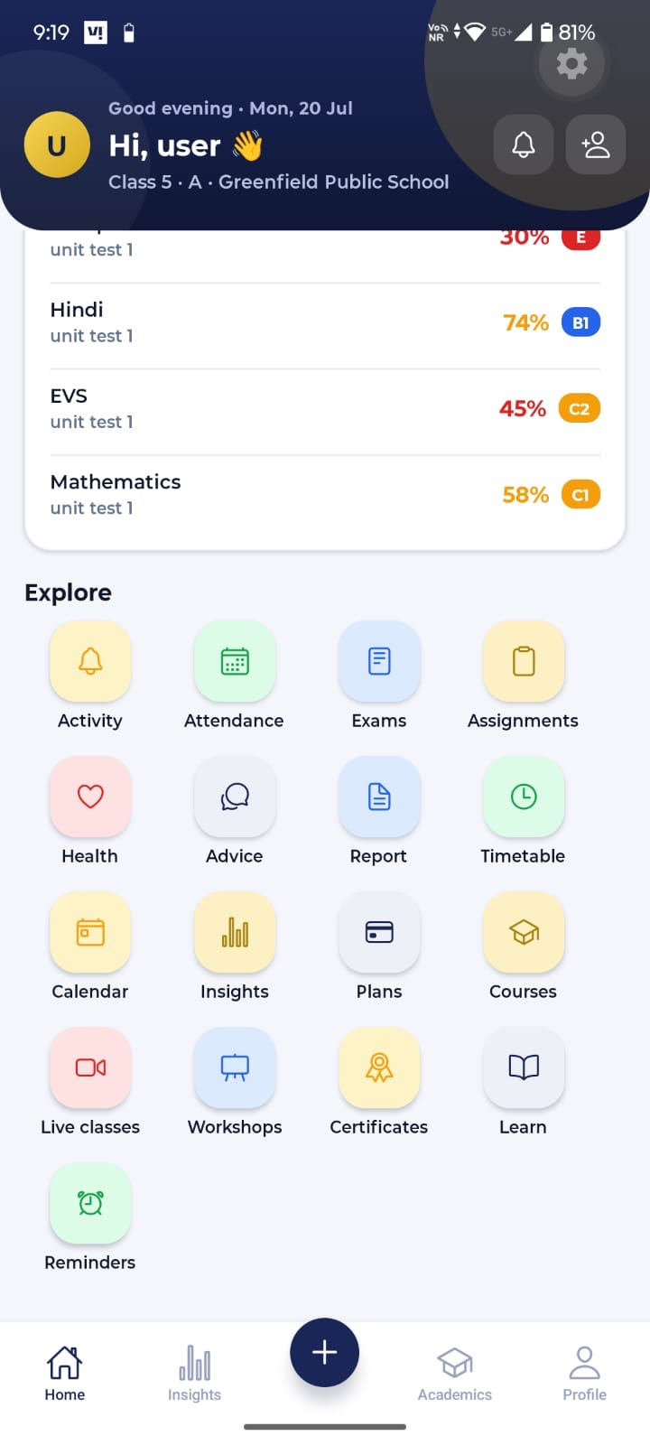 | Notes  13. ‘Explore’ section is very clustered and does not look good, change to simple and easy to use navigation style - DONE

Recent Marks
Screen 1 Recent Marks
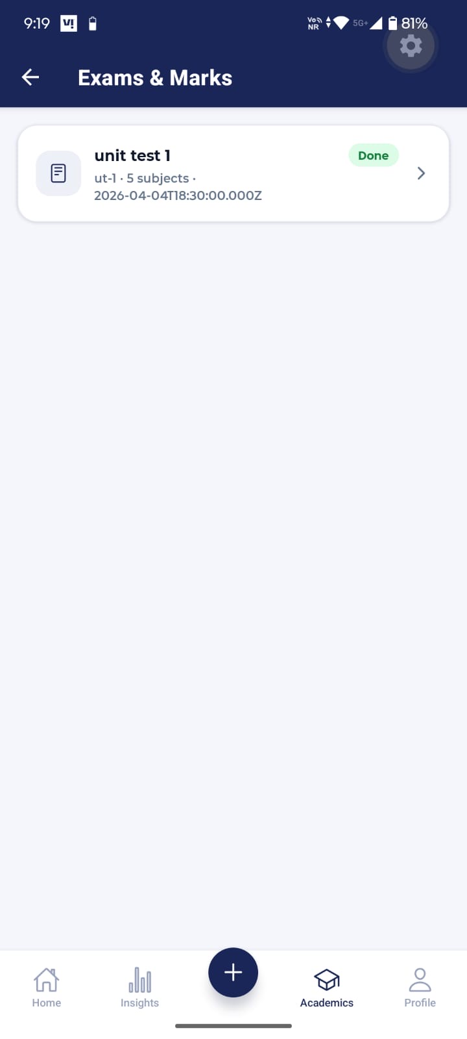 | Notes  14. Instead of ‘Done’ write ‘completed’ and others should be ongoing and upcoming - DONE  15. Shorten the time stamp, show exam start and end date - DONE  16. How would you sort between completed, ongoing and upcoming? Which one would you show at the top?  - Ongoing exams will show on top and then upcomming in middle and the completed in bottom.

Screen 2 Recent Marks
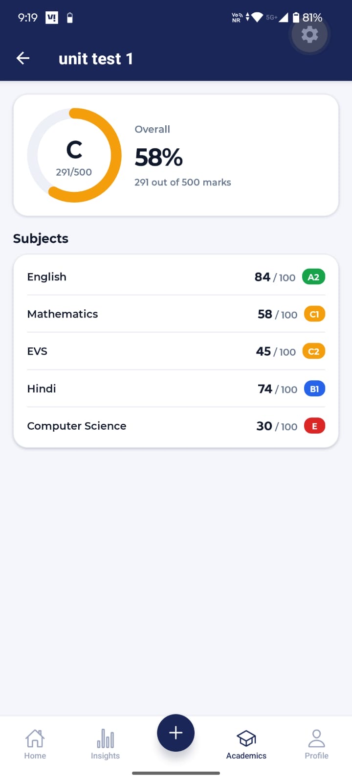 | Notes  17. 291/500 is shown twice, show this only once and show grade only if used by school otherwise show the percentage and can also show exam start and end dates – DONE  18. I want to add one additional feature to all the dashboards wherever possible - comparison with peers. Like here, we can show class average or class median or class highest (not for every subject but at an overall level), and this would help parents plan better. But this could be a controversial feature so don’t make this permanent, keep the flexibility to hide/unhide this feature but add this wherever possible  19. The above feature would be good to have in the web application as well; we can plan to add this while incorporating the feedback (I’ll share the feedback for the dashboard as well)  20. We can also include some insights here with each exam like if the percentage has gone up or down as compared to the previous exams (this would help track the journey throughout the year) - we can discuss this in detail  21. We can also create a subject wise journey throughout the year, like if someone clicks on English here, then he/she is able to see the progress in the form of a graph or table (we cannot use absolute marks for this as base could be different of different exams but we can plot percentage against each exam and this will help with tracking or we can create a separate section for this (whatever you feel is better and convenient) but we would also need this in the web version

Activity Tab
Screen 1 Activity Tab
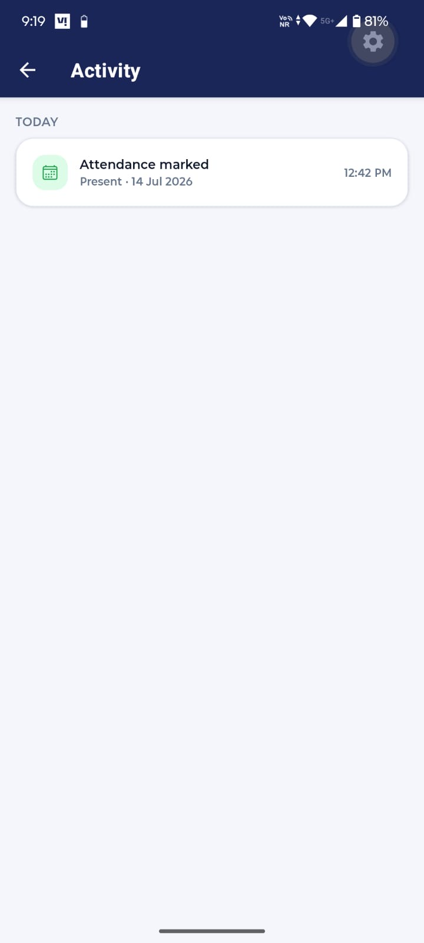 | Notes  22. Try to see if we can merge activity and notifications together, I don’t want the app to send more than 2 notifications each day to the user, so if it becomes that combining both would create a problem then we can keep these separate

Attendance Tab
Screen 1 Attendance Tab
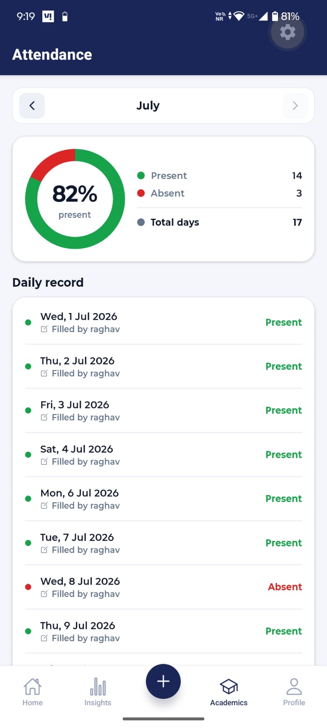 | Notes  23. How would you account for half a day here?- Half Day currently count as zero in the calculation of percentage, also the late credits 1 towards percentage .  We can apply the 0.5 half-day credit across all the attendance-percentage  24. Would users be able to access previous sessions data? - YES, I HAVE ALREADY CONFIGURED IT.  25. How would this section look like for students whose schools are not affiliated with us? Should we allow parents to record attendance here if school is not providing this data? - can discuss this  For the not affilated students, i have already added the contributor page where student can give access to any contributor (one at a time) and the data added by the contributors will show on the same pages , user can select from the dropdown its old enrollment or self-tracked data.

Screen 2 Attendance Tab
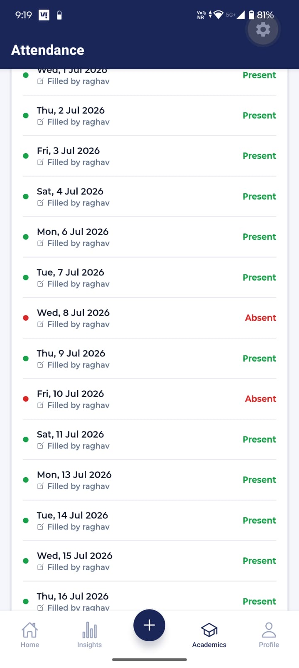 | Notes

Screen 3 Attendance Tab
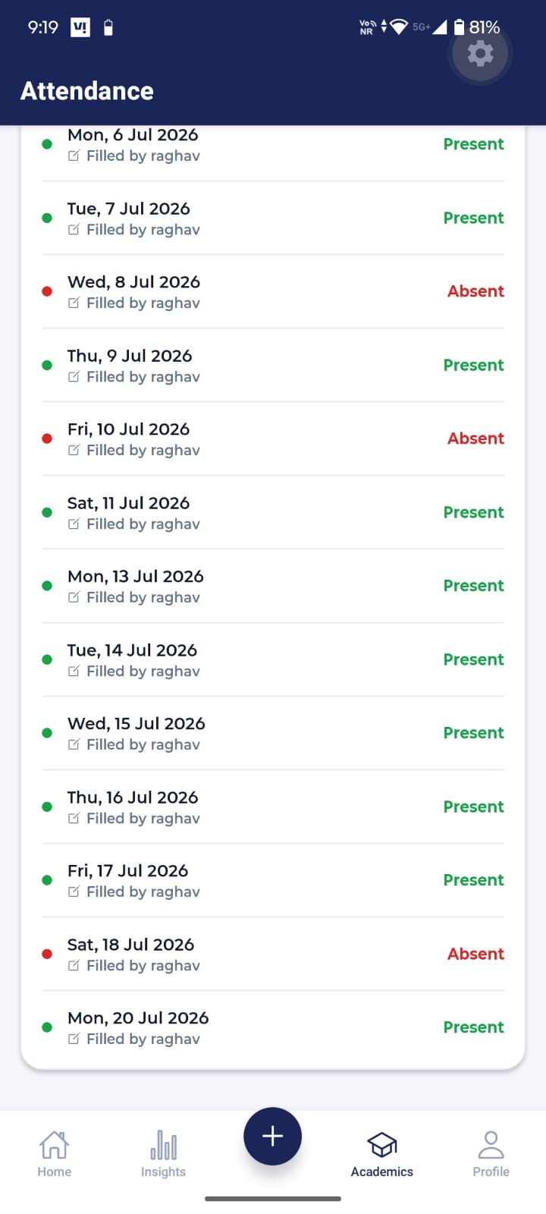 | Notes

Screen 4 Attendance Tab
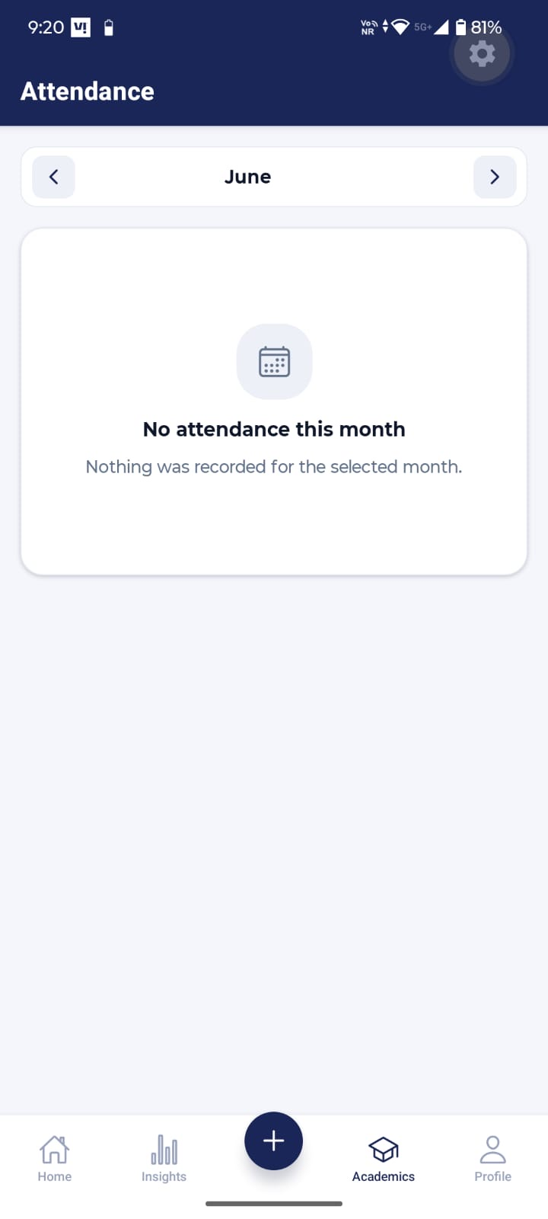 | Notes

Notification Bell Icon
Screen 1 Notification bell icon
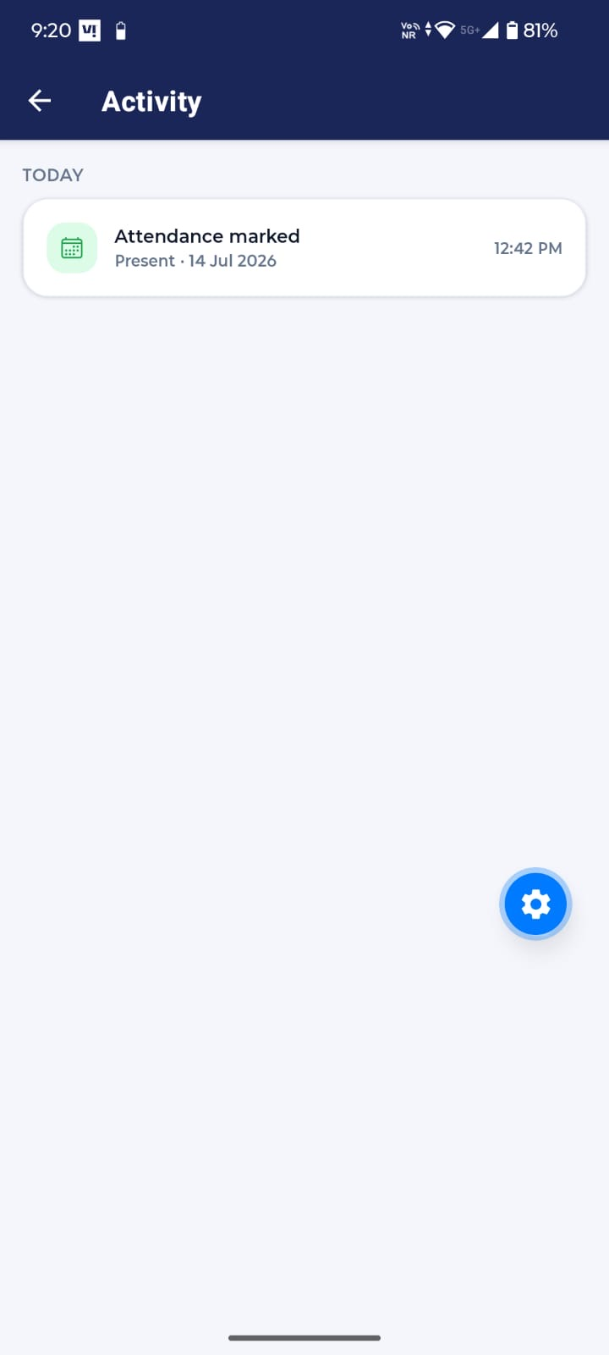 | Notes

Account (Icon beside notification bell)
Screen 1 Accounts
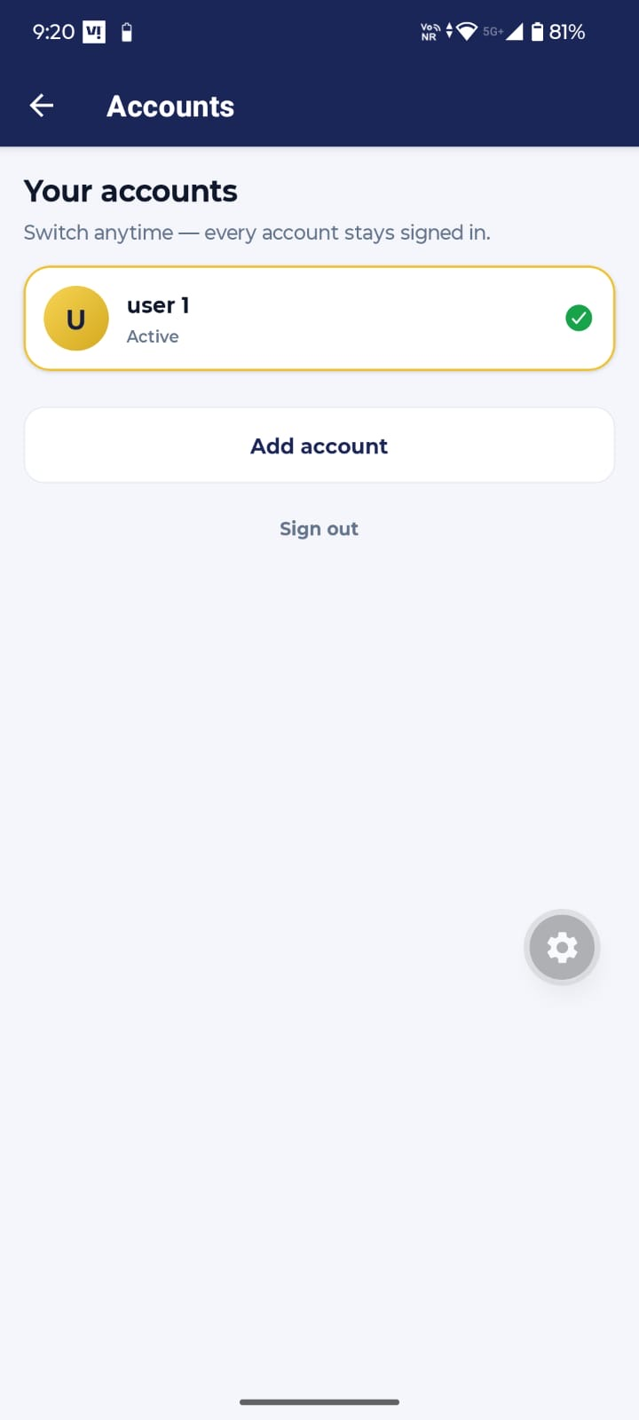 | Notes  26. Sign out should be separate for both accounts and if it’s one button then ask which account they would like to sign out off  - DONE  27. How many accounts can one user login? - There's no hard limit — currently a user can add unlimited accounts on one device, until it exceeds the secure storage capacity,  Now i have added a max cap of 4 accounts.  28. Apply checks like user cannot login into the same account twice – Already Done

Screen 2 Accounts
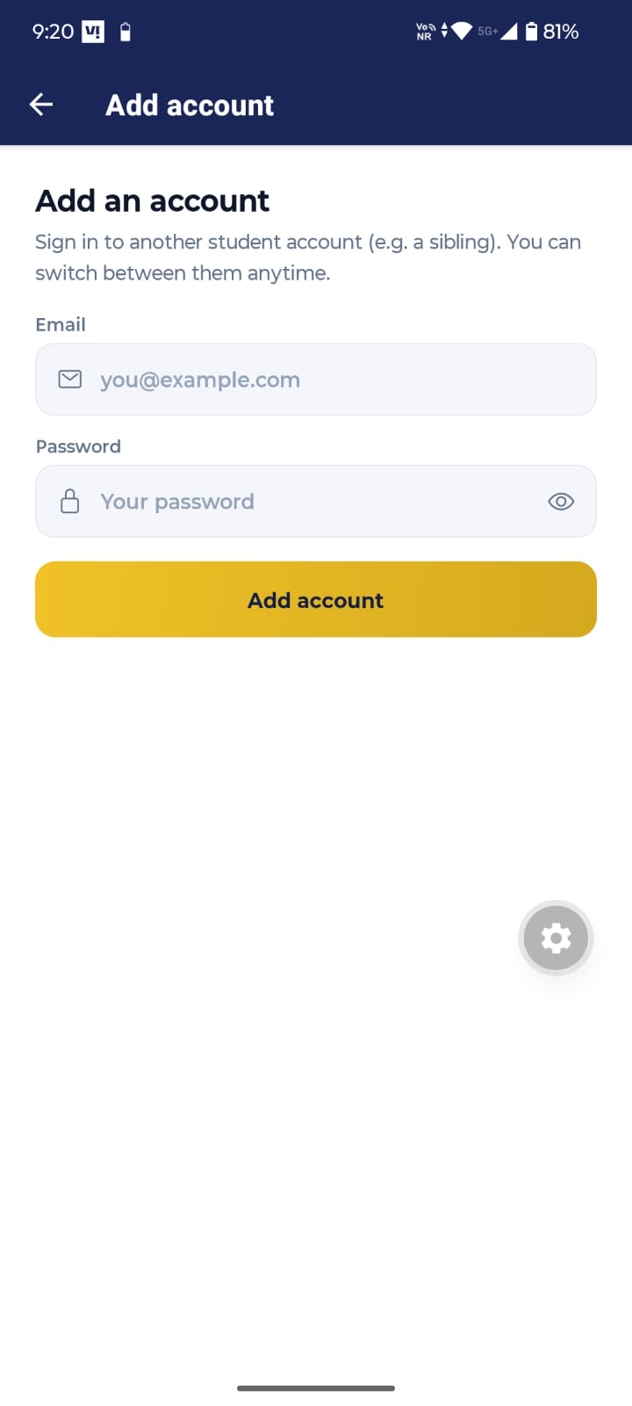 | Notes  29. Would this step need OTP verification? - can discuss  - I think it does not require otp verification, as otp verification is only used for signup and password resets.

Assignments Tab
Screen 1 Assignments
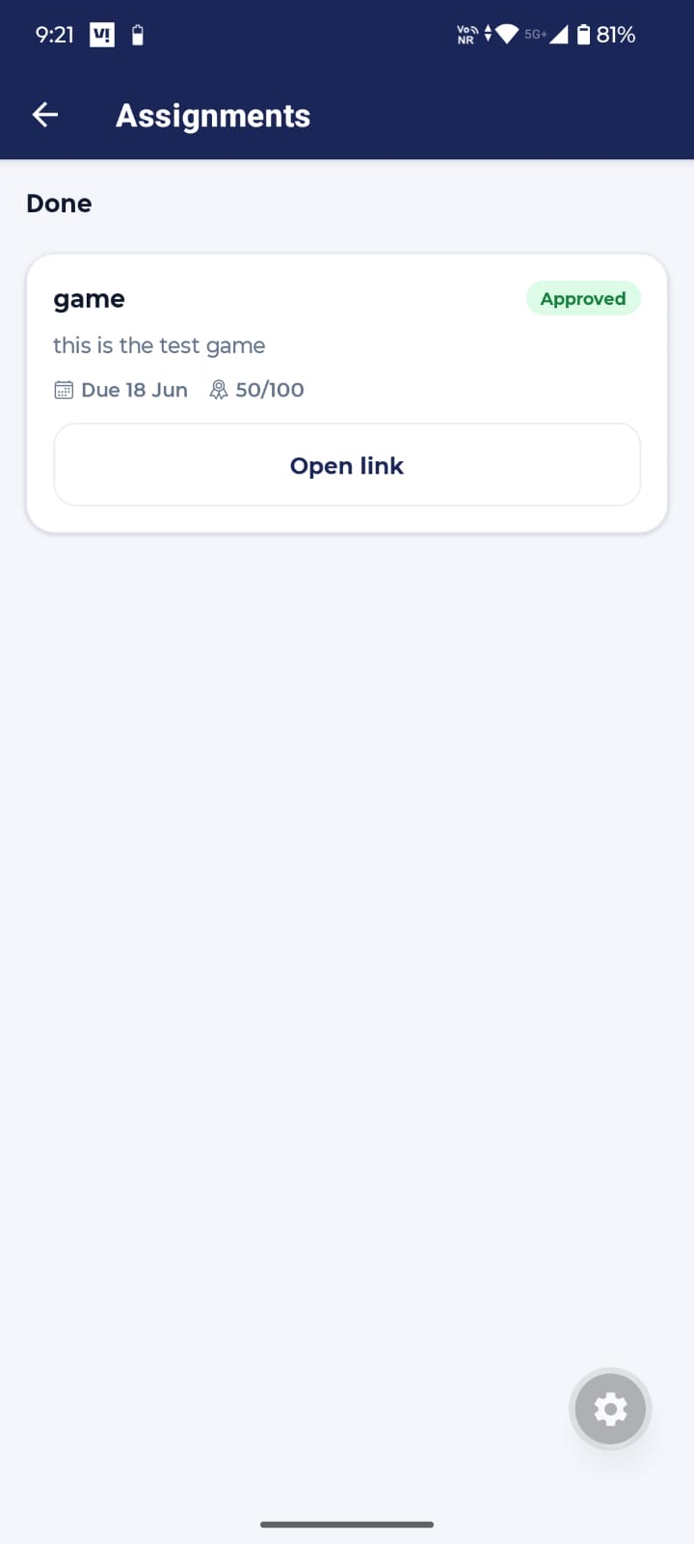 | Notes  30. Write ‘Completed’ instead of ‘Done’  Student's assignments is defined in two lists by the system:  "To do" — assignments they still need to submit.  - "Done" — assignments they've already submitted.  The life of one assignment  Think of one assignment moving through 4 stages:  - To do (yellow tag) — just given, not submitted yet. The student sees a "Mark as submitted" button.  - Submitted (blue tag) — the student tapped that button. It now moves from the "To do" list down to the "Done" list.  - Approved (green tag) — the teacher/consultant checked it and accepted it. Marks show up.  - Rejected (red tag) — the teacher checked it and did not accept it.  31. Build a reminder system for assignments/Quizzes/Games that reminds close to the due date if the task is not completed

Health Tab
Screen 1 Health
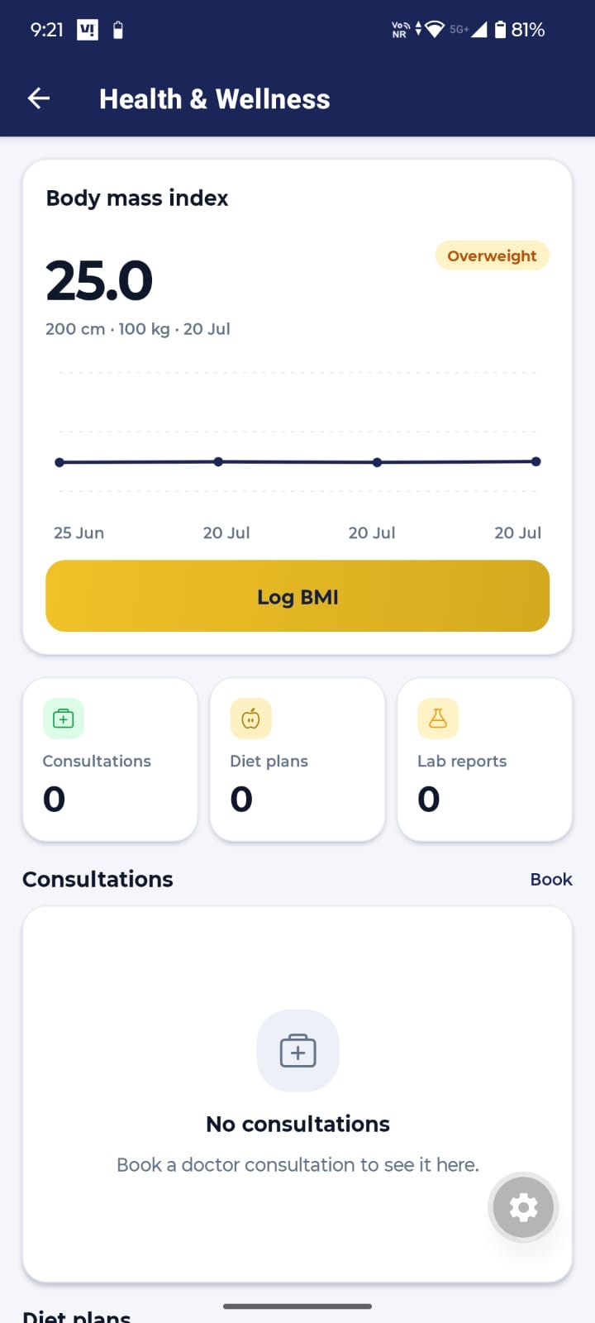 | Notes  32. We might need more inputs from parents like screen time, mood tracker, activity tracker – this is something we’ll do later but you can plan for these as well  33. If ‘Book’ here allows user to book appointment then write ‘Book Consultation’ or ‘Schedule Consultation’ and use the same word (book or schedule) throughout all the dashboards for all doctors related items – I prefer Schedule as it’s more formal : DONE  34. If ‘Book’ refers to previously booked consultations then use ‘Booked’, or ‘Scheduled’ or ‘Previous Booked’ : Book is for new consultation, i have changed the text to Schedule Consultation.

Screen 2 Health
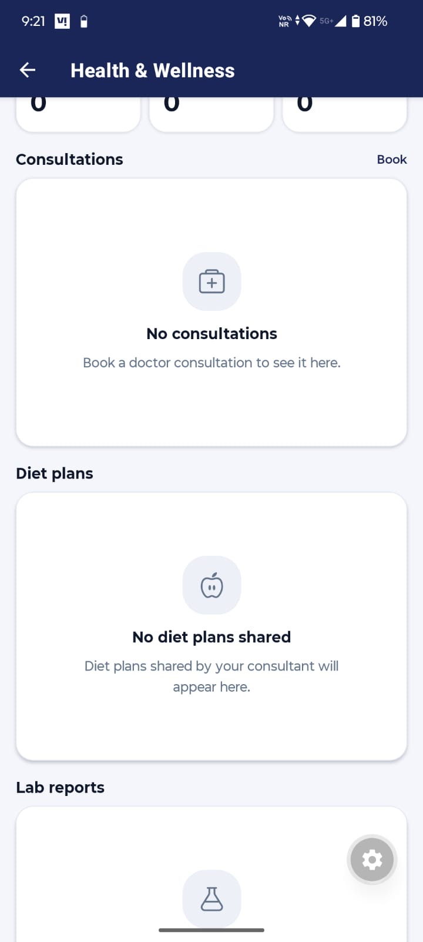 | Notes

Screen 3 Health
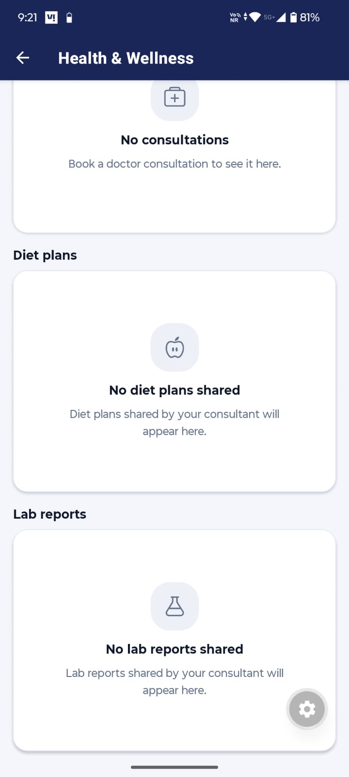 | Notes

Screen 4 Health
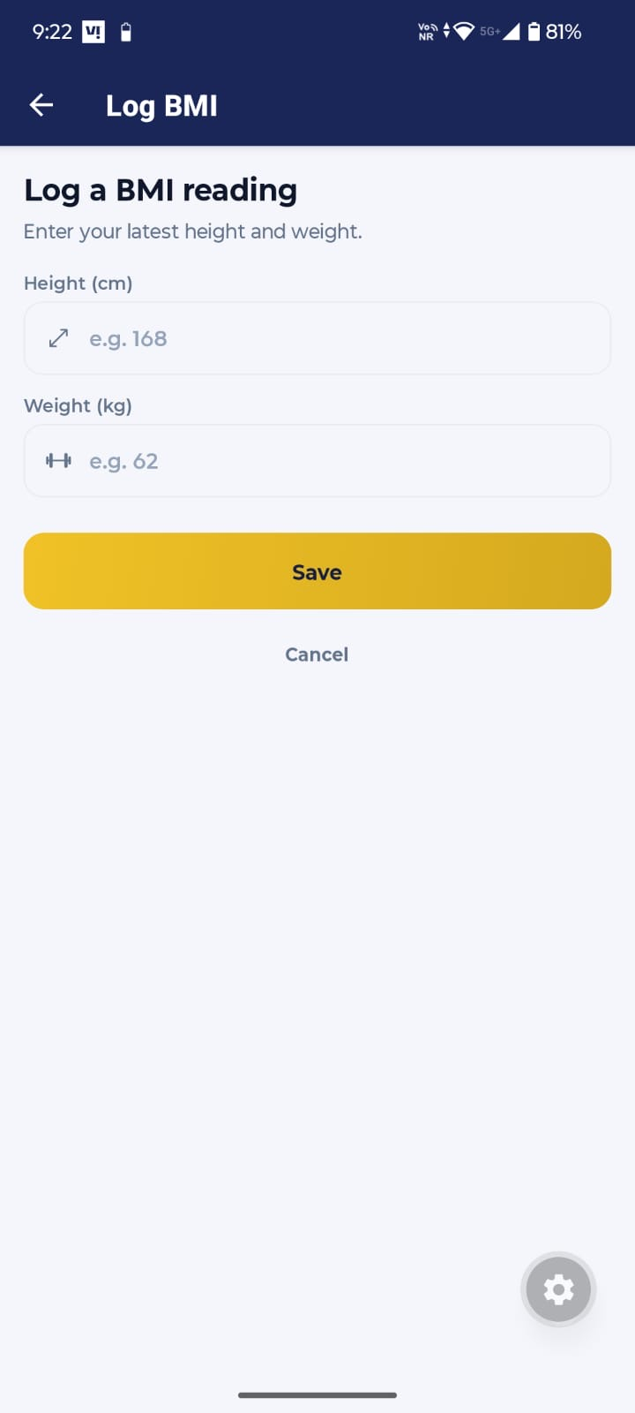 | Notes  35. Do not use the word ‘your’ as it might be a parent who might be using the app or a child and this can get confusing : DONE  36. Apply some sanity checks like height cannot be 1000cm or wight cannot be 500, I don’t want user to accidently enter wrong data or ask once before submitting or allow an option to edit the entries as there is very high possibility that someone might enter wrong data : DONE

Health Tab – Consultation – Book Tab
Screen 1 Book a Consultation – Request Form
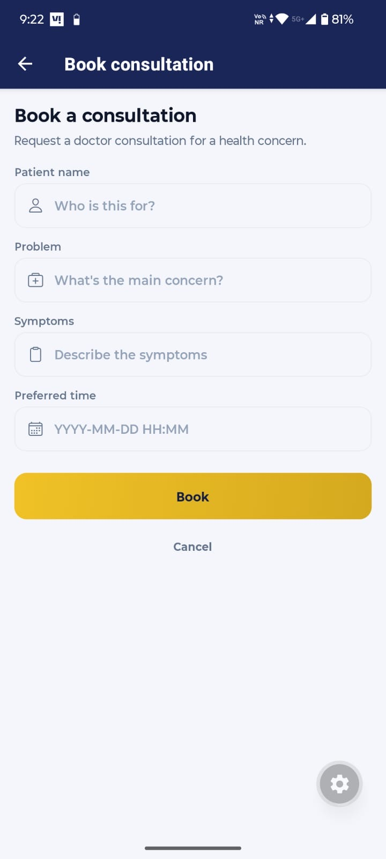 | Notes  37. The doctor consultations would be strictly allowed for the child and so do not ask for the child’s name, instead keep this a pre-filled field or do not show this at all – we can expand this feature later to allow booking for others as well but that would incur extra cost (to be done later) : DONE  38. We’ll need to sync the preferred time option with Doctor’s Calander so that there is not back and forth and there is no double booking – if a slot is filled by another parent than that slot should not be visible to others (and this entire feature might not be needed in the beginning so keep an option to hide this from the app)  39. There should also be some limit on far in the future one can book an appointment : Currently, I have added 3 consultations per month.C

Advice Tab
Screen 1 Advice
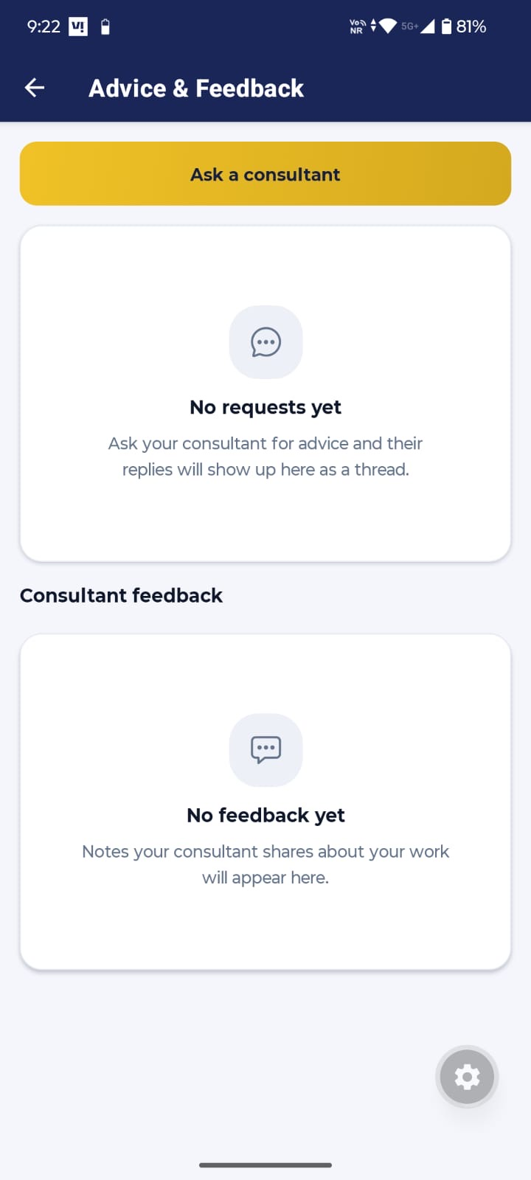 | Notes  40. Write ‘Ask Consultant’, we’ll have one fixed consultant for each student. : DONE  41. The wording ‘your work’ does not seem right as this would be mostly used by parents and work is not the right word here, it could be ‘about your child’ or ‘about your ward’ or anything else but do not use your work : Done

Screen 2 Advice Tab
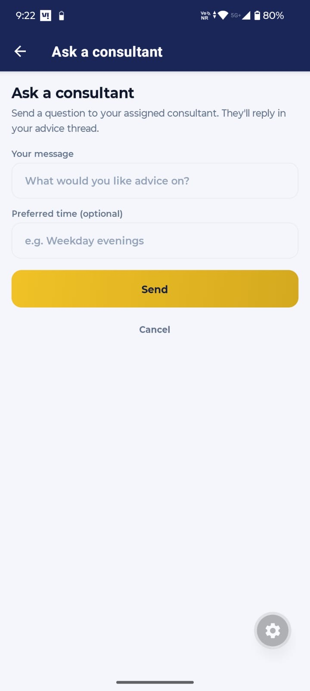 | Notes  42. Keep “Ask Consultant” constant across all pages and dashboards : DONE  43. Add a description or small note that if you want to connect over a call then select the preferred time slot otherwise leave it blank

Report Tab
Screen 1 Report Tab
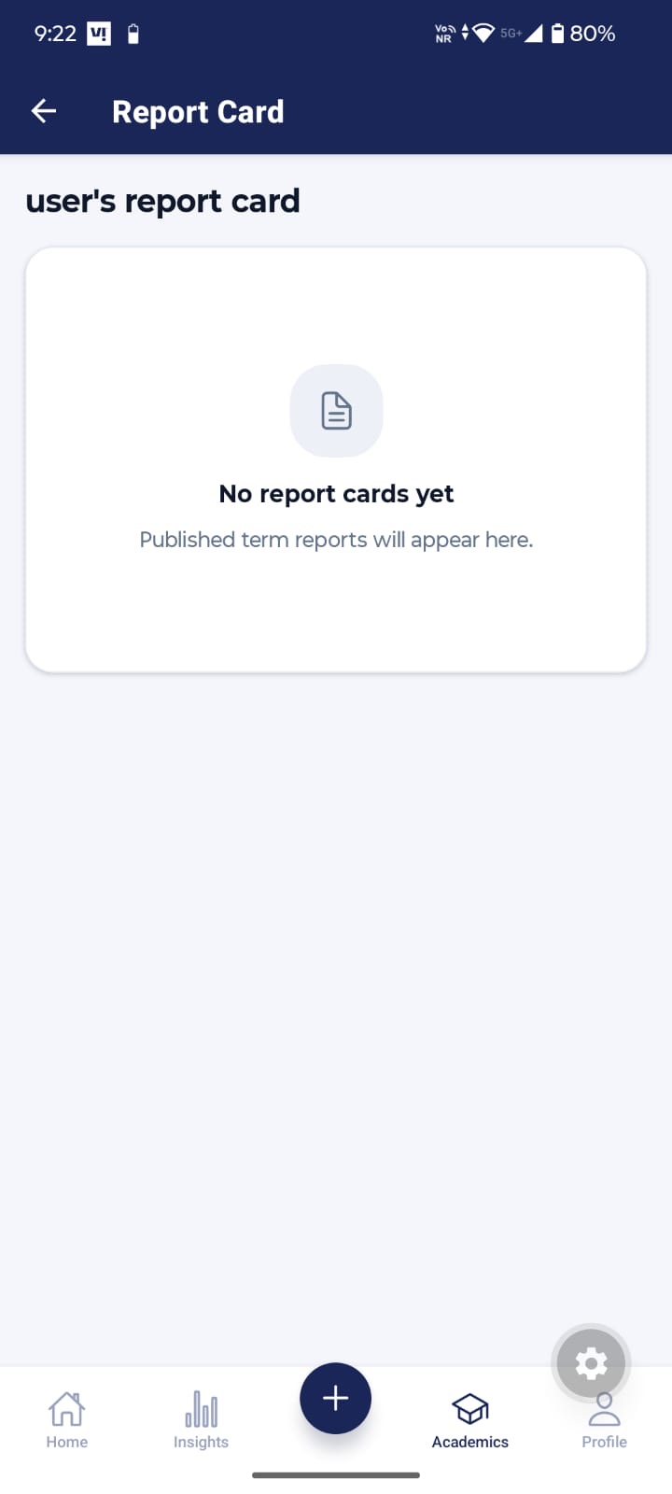 | Notes

Timetable Tab
Screen 1 Timetable
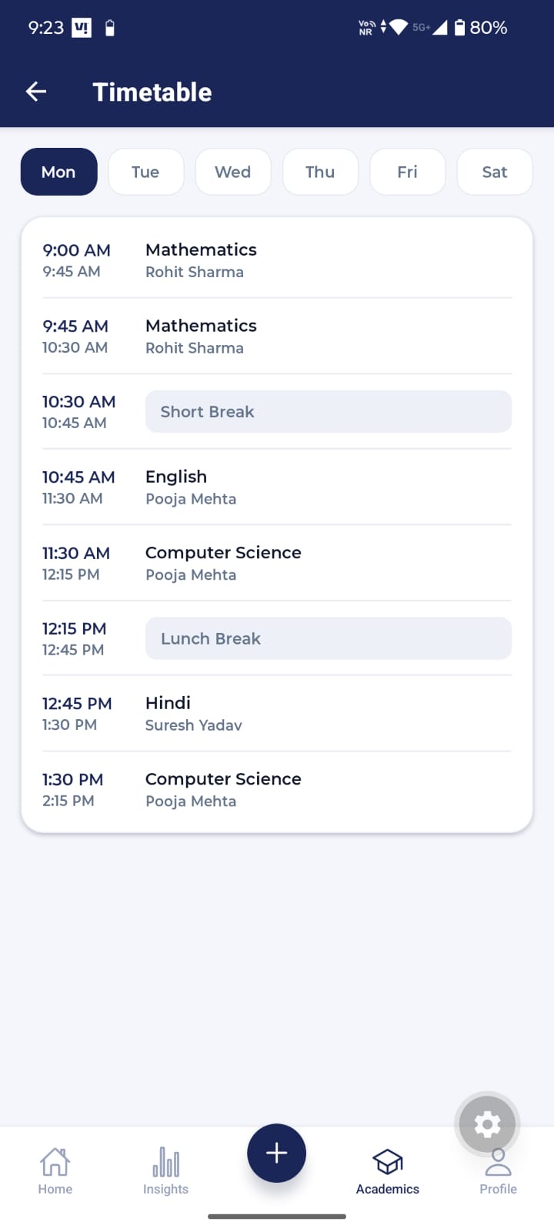 | Notes  44. In future, we can add a feature in the school dashboard to add homework for the entire class through our dashboard (like read chapter 6, do exercise 2.1 or complete this assignment) or application and that would be visible in our application

Screen 2 Timetable
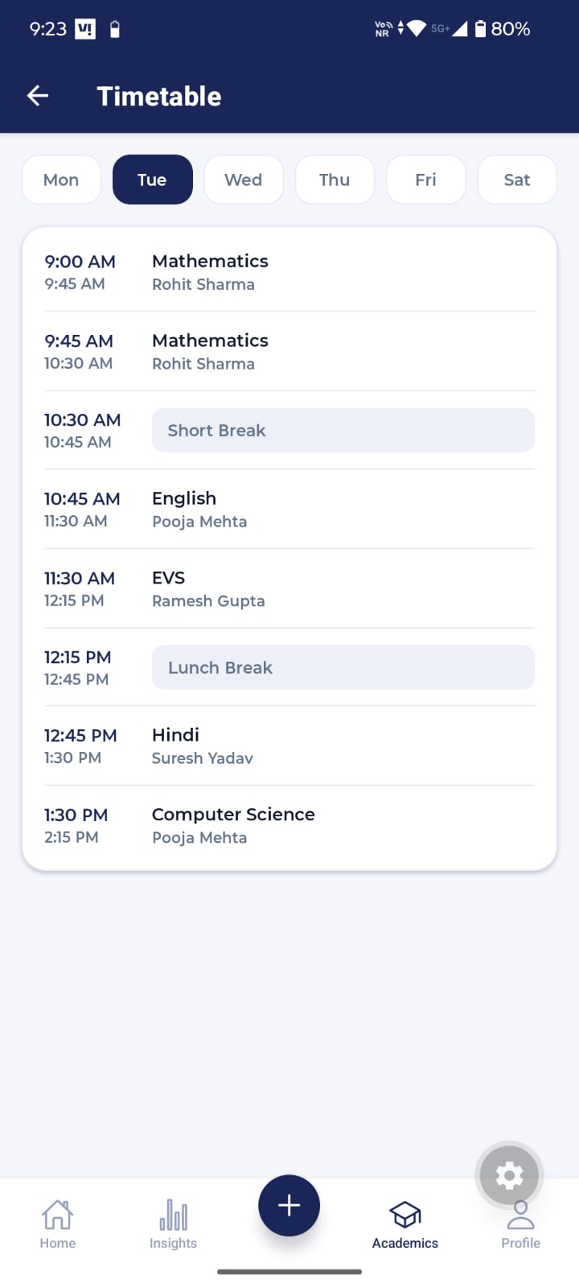 | Notes

Calendar Tab
Screen 1 Calendar
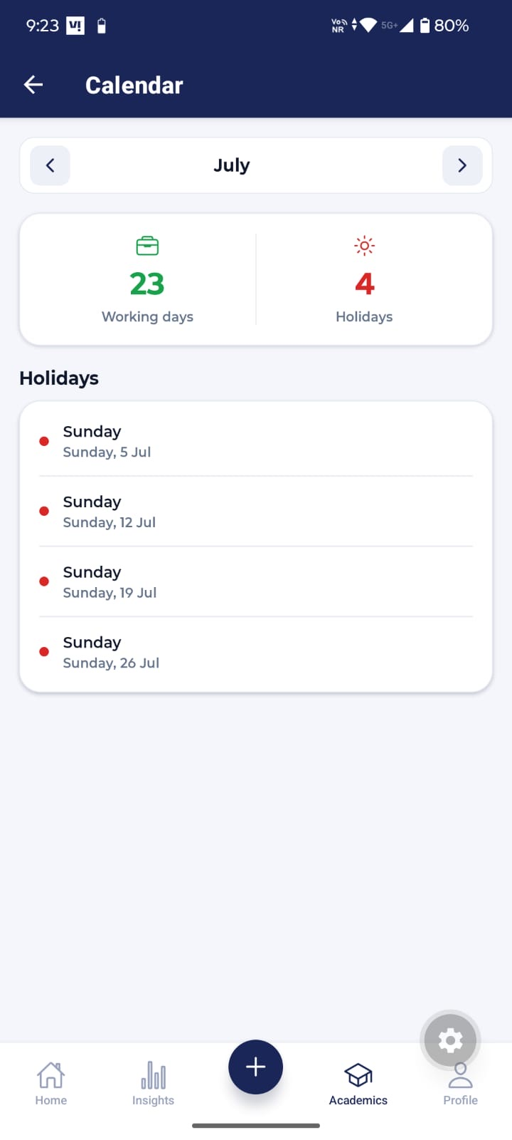 | Notes  45. We should keep one Calander for all the events – school holidays, yoga/meditation sessions, webinars or seminars, consultations etc. So that user is able to track everything easily and this should be done for the web application as well – we should discuss this in detail before implementation

Screen 2 Calendar
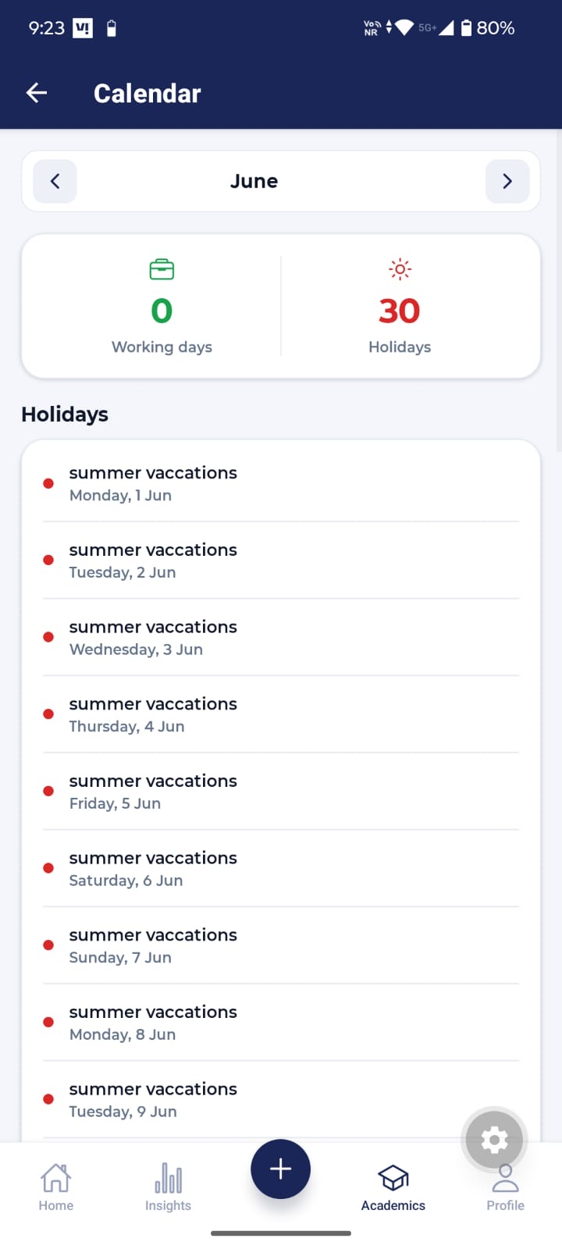 | Notes

Screen 3 Calendar
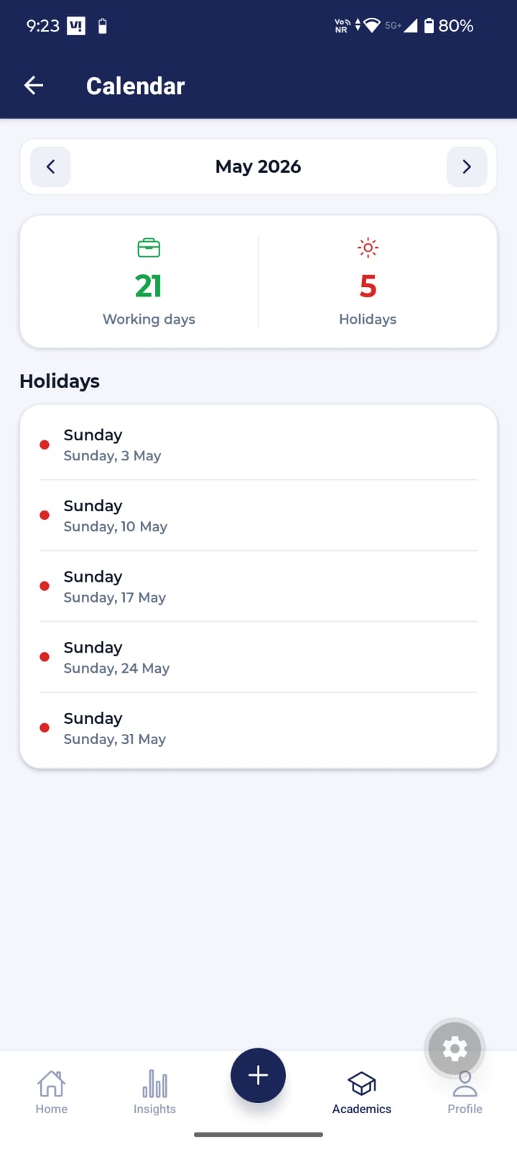 | Notes

Insights Tab
Screen 1 Insights
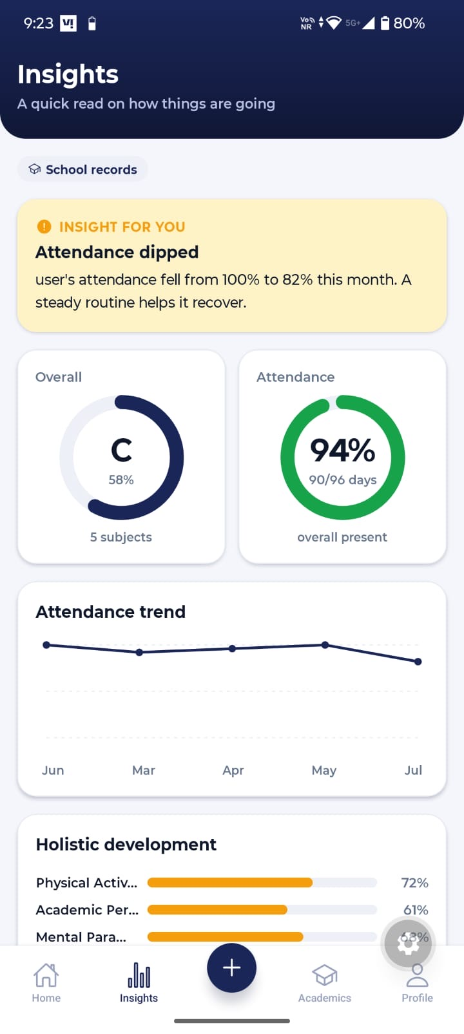 | Notes  46. All insights should have comparison to some previous data so that it’s easier to understand the growth or decline and user is able to see a journey  47. Later we would use this data (holistic data, attendance, marks, teacher’s feedback etc.) to enable the parents make better decision on what’s good for their child and for that we would need a feature to compare data across years or sessions, this can be done later like when 2 sessions are over, we should have some comparison between them, how the child has progressed  48. Insights need not to be academic only, if there is something from health and finance section that can be shown here, then we can include that as well

Screen 2 Insights
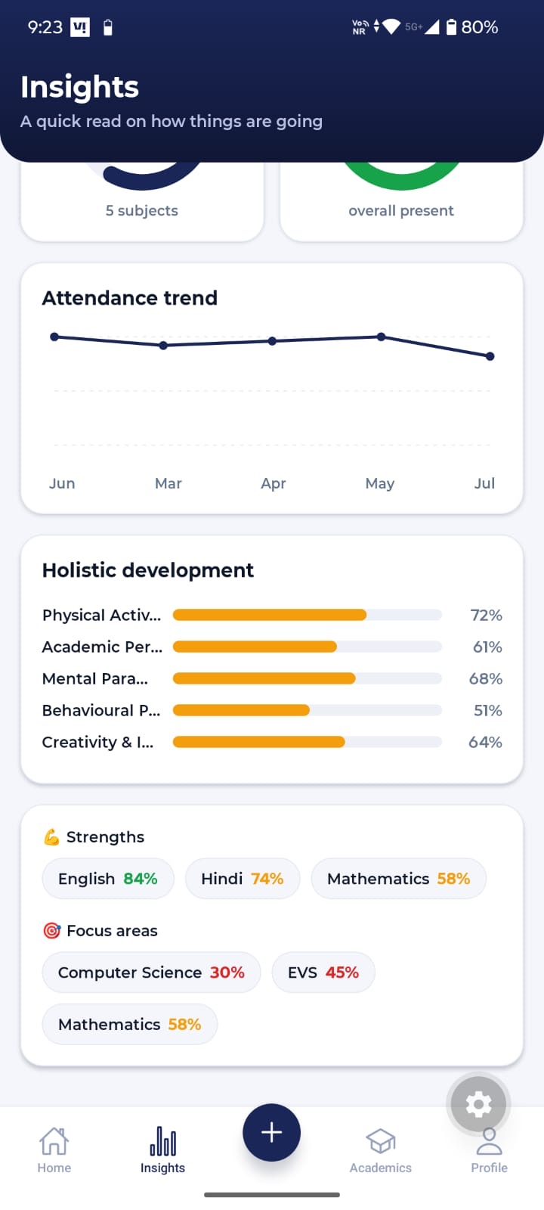 | Notes

Plans Tab
Screen 1 Plans & Subscription
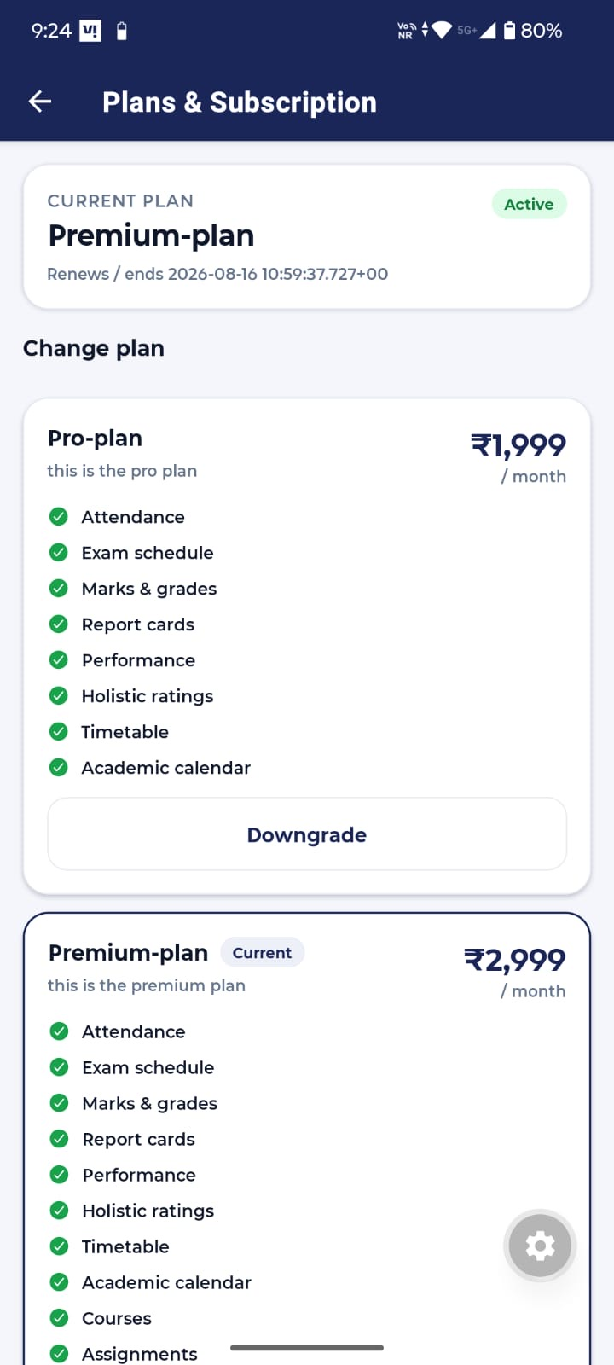 | Notes  49. Shorten the time stamp, no need to show time – Already Done  50. Highlight what’s better in the premium plan when compared with other plans, this can be done in multiple ways – one could be to highlight what’s new or additional in the premium plan (make it bold or use different color) or write ‘Everything in pro plan + below mentioned features, we have to show why we are charging extra for pro plan -DONE  51. One thing that I mentioned above, a feature for peer comparison (how that child is doing with respect to others in his class or school) - we can keep this a separate feature that can opted with premium plan only and parents should provide consent to use this feature as this can cause some problems if precautions are not taken  52. Do not write ‘this is the pro plan’, instead write something like ‘below are the features included in the pro plan’ or do not write anything at all  -Yes this is not hardcoded text, this text will be added by the super admin while creating this plan.

Screen 2 Plans & Subscription
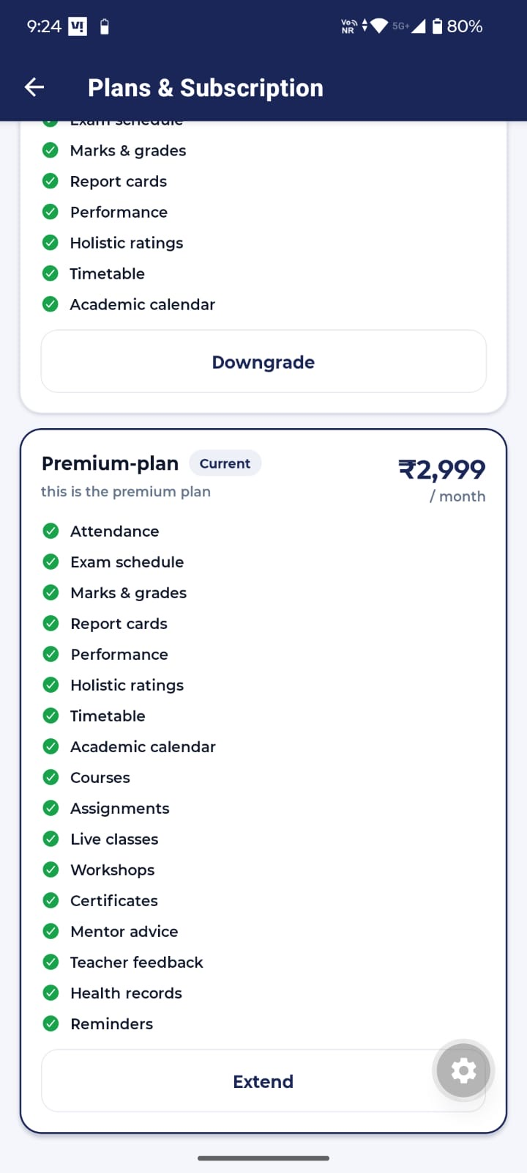 | Notes

Courses Tab
Screen 1 Courses
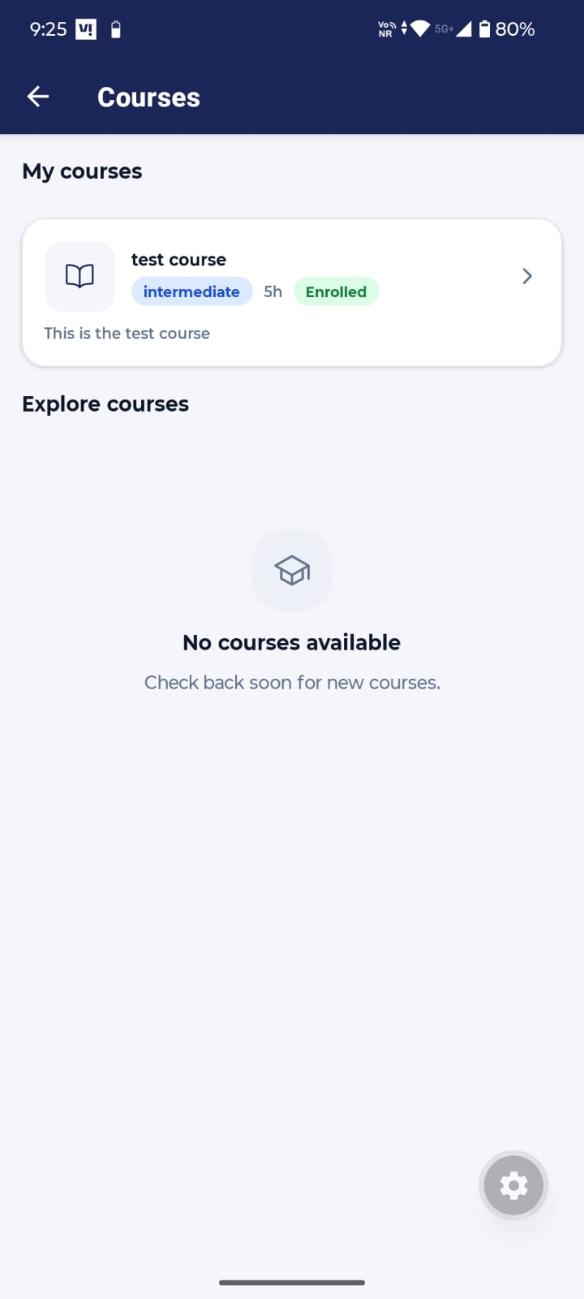 | Notes

Screen 2 Courses
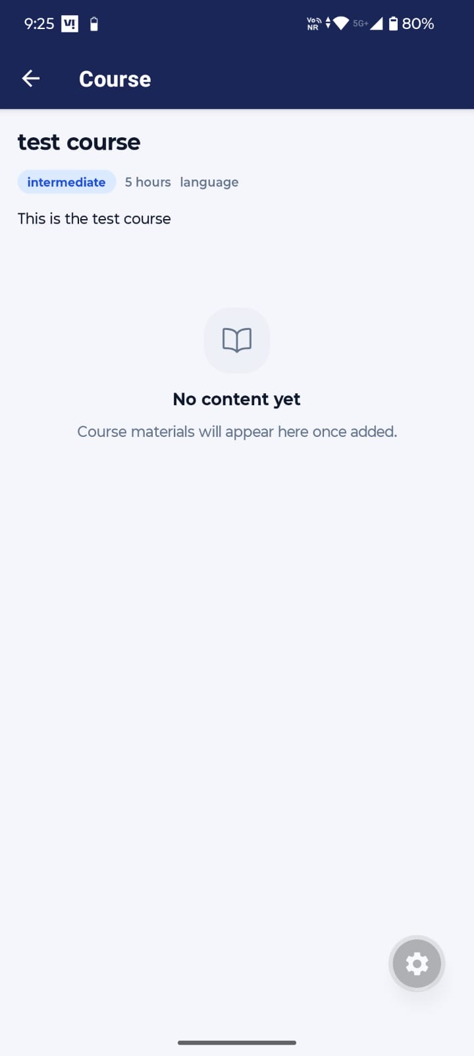 | Notes

Live Classes Tab
Screen 1 Live Classes
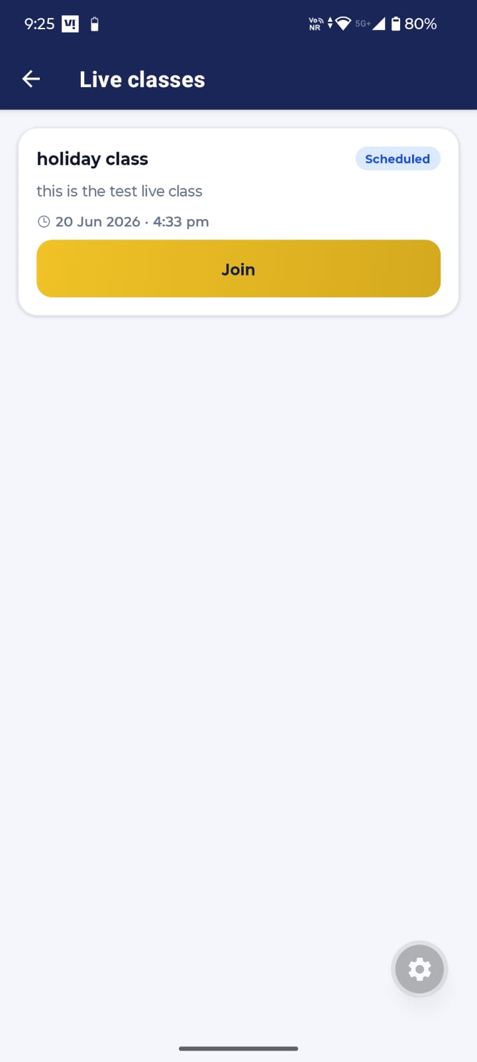 | Notes  54. need to discuss this  I have now configured the live classes page  - Live classes are now automatically organized into Live Now, Upcoming, and Past sections.  - If a class has already ended, it will appear under the Past Section.  - Students will only see the Join button for classes they can actually attend.  - Past classes will instead show a Recording button (if a recording is available) or no action button.  - Dates and times are displayed correctly according to the student's local time zone.  Sort Order  - 1. Live  - 2.Upcoming  - 3.Past

Workshops Tab
Screen 1 Workshops
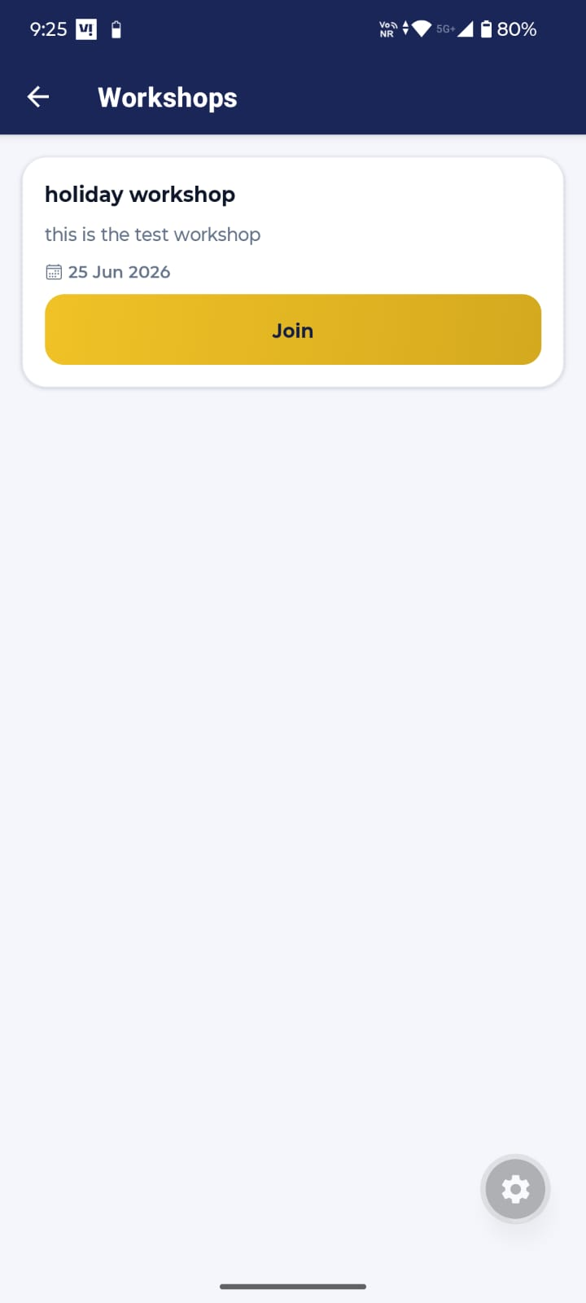 | Notes  55. Need to discuss this  I have now configured the live classes page  - Workshops are automatically divided into Upcoming and Past based on their scheduled date.  - Past workshops are clearly marked as Ended and no longer display a Join button.  - Upcoming workshops continue to show the Join button whenever a meeting link is available.

Certificates Tab
Screen 1 Certificates
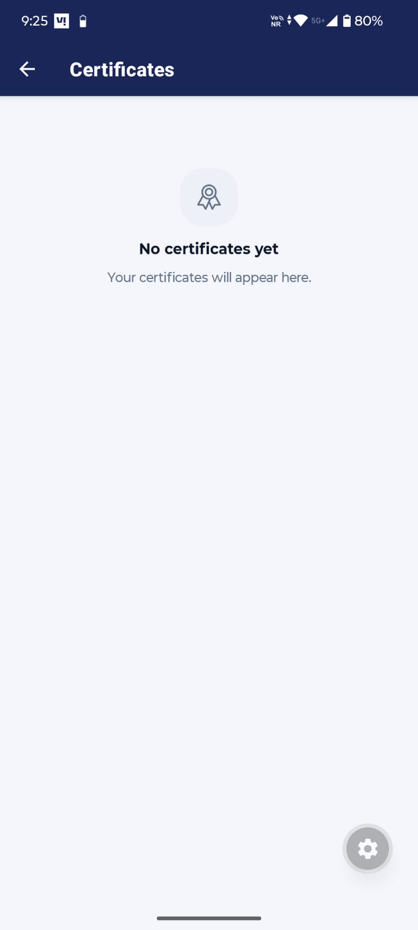 | Notes  56. Caution with using the word ‘your’ : DONE

Learn Tab
Screen 1 Learn
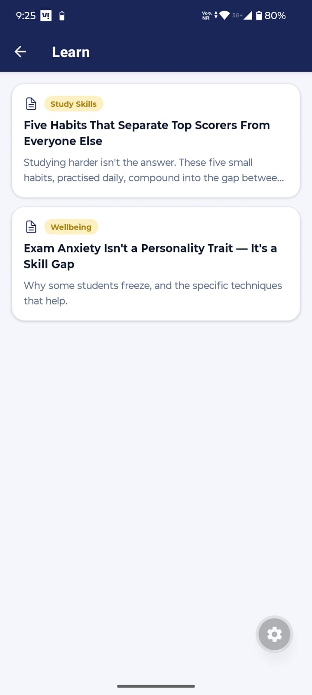 | Notes

Screen 2 Learn
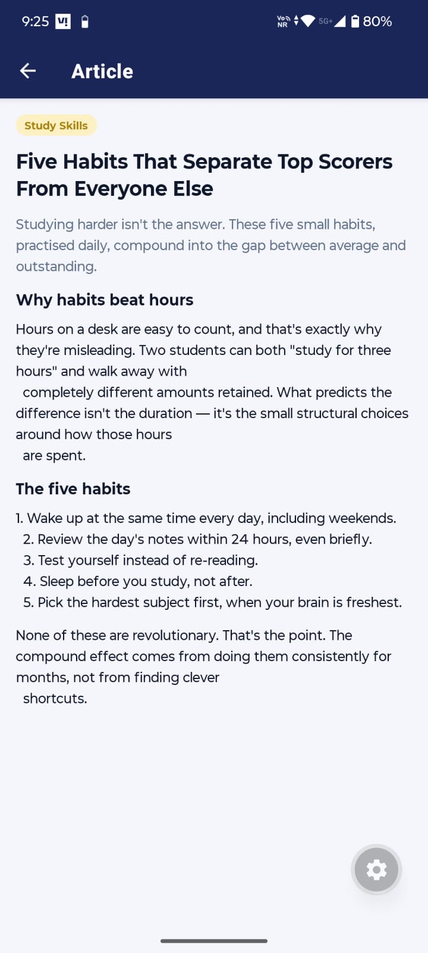 | Notes

Reminders Tab
Screen 1 Reminders
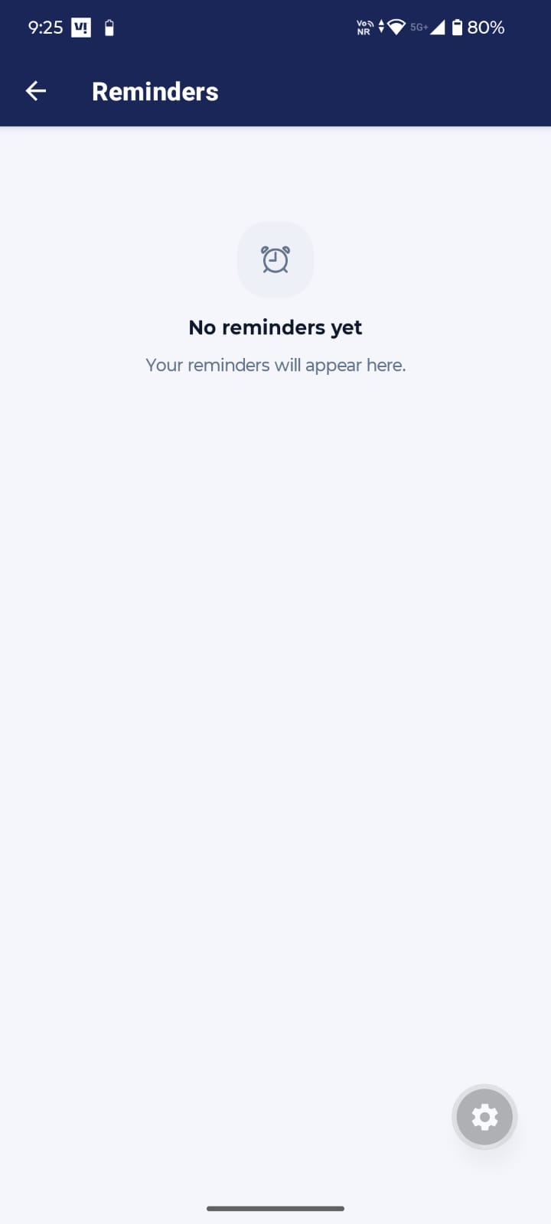 | Notes

+ Sign Taskbar (Quick Actions)
Screen 1 Quick Actions – Menu
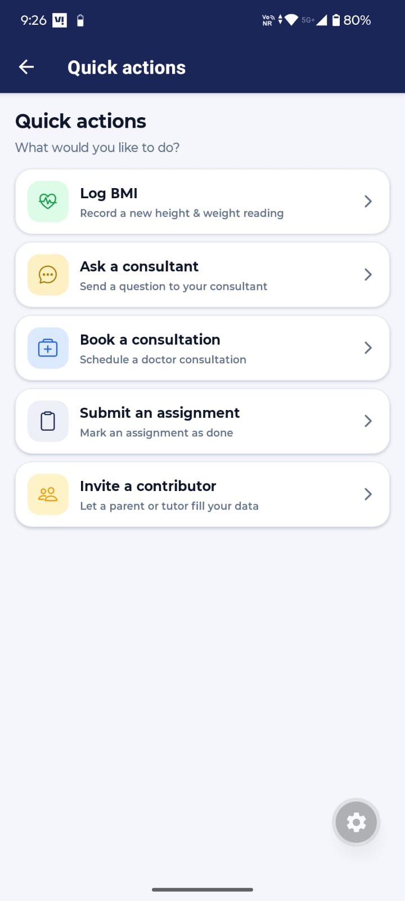 | Notes

Screen 6 Quick Actions – Invite Contributor Form
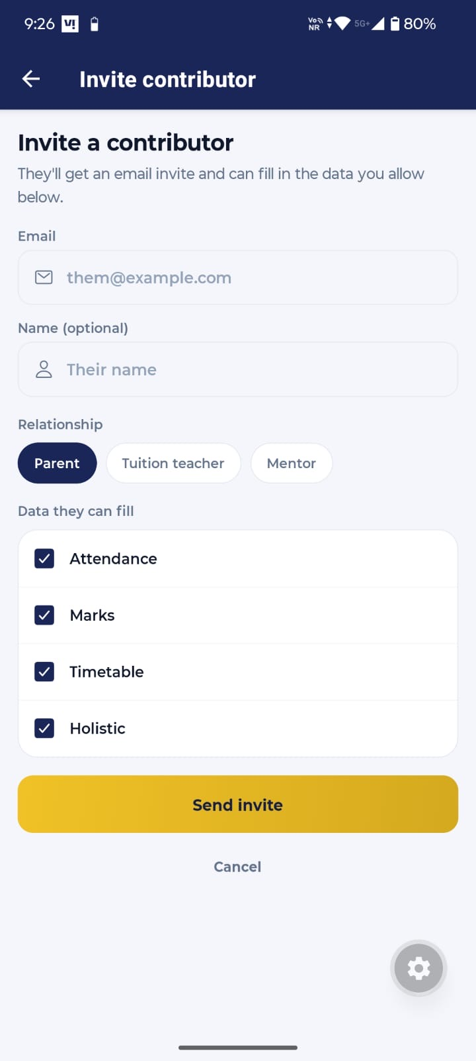 | Notes  57. How can one remove a contributor, and would the old data be deleted if a contributor is changed?  The students who are not affiliated with any school can add one contributor at a time and can also revoke access. Also, the old contributor data will not be deleted and will be shown on the student academic pages.  58. Would the contributor receive a link and a guide on how to fill out the details?  Yes, contributors will receive a link to add password for their dashboard, and i will add a simple guide in that contributor dashboard, like how to add student data.

Academics Taskbar
Screen 1 Academics
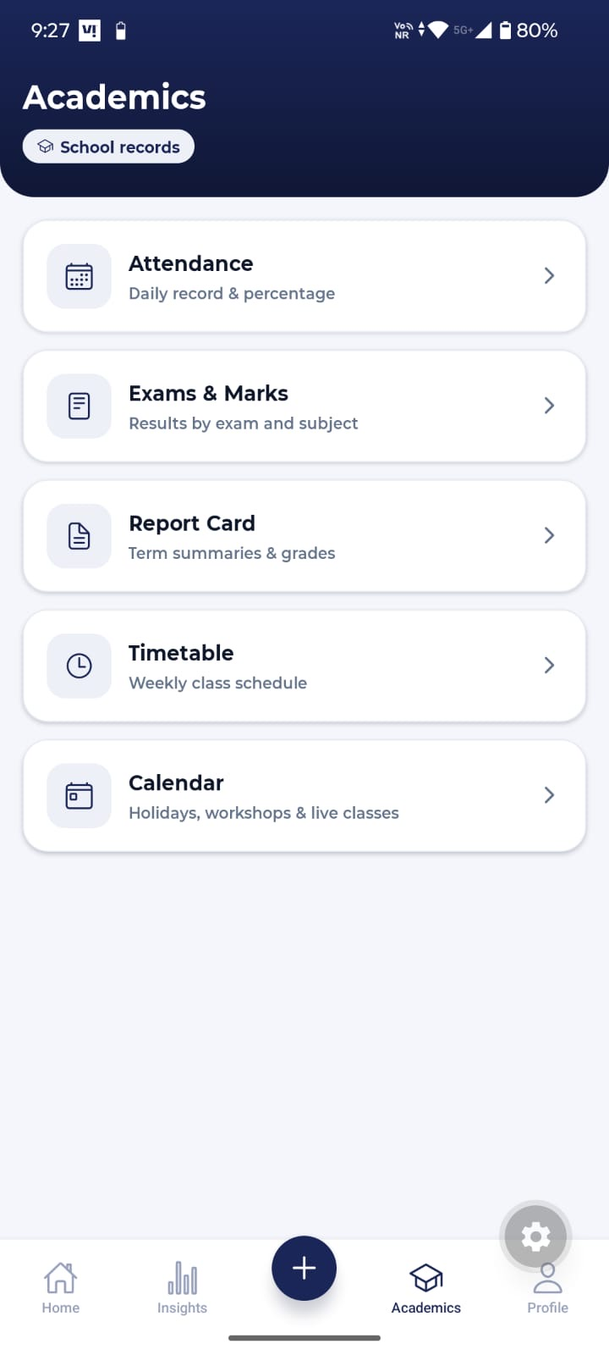 | Notes

Profile Taskbar
Screen 1 Profile
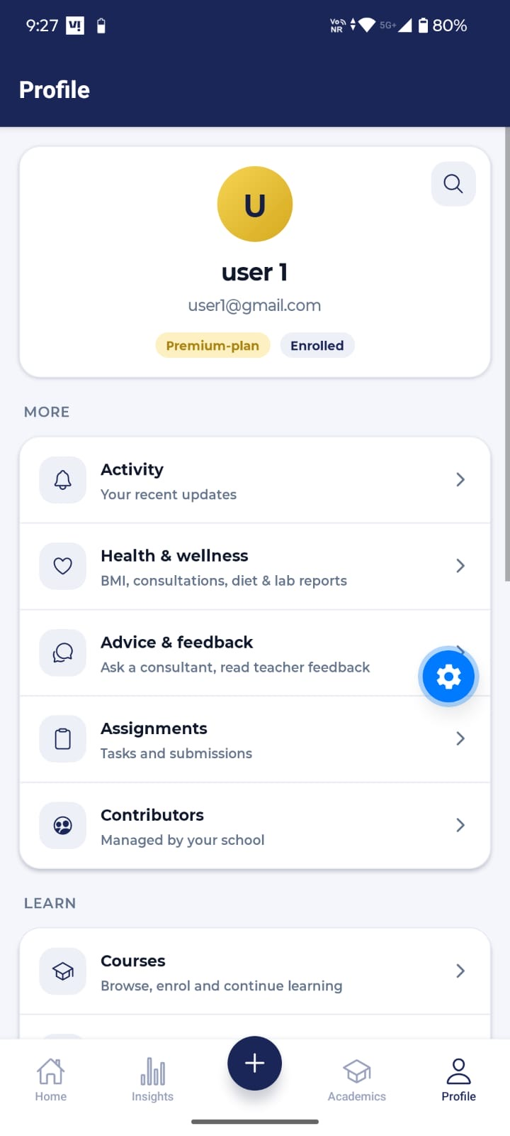 | Notes  59. Allow user to upload a profile picture -DONE

Screen 2 Profile
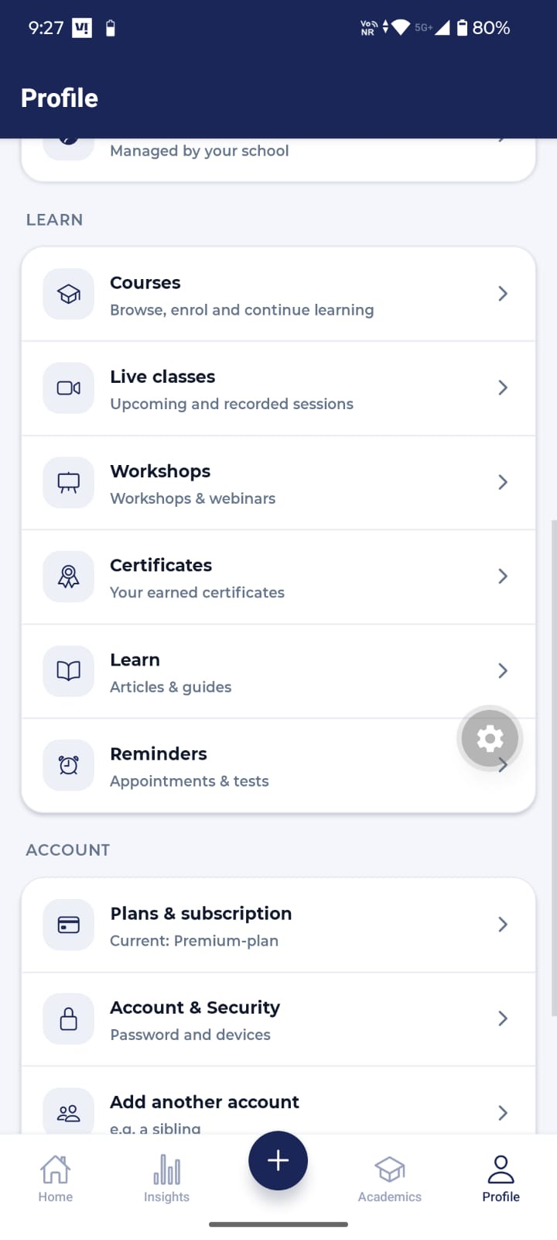 | Notes

Screen 3 Profile
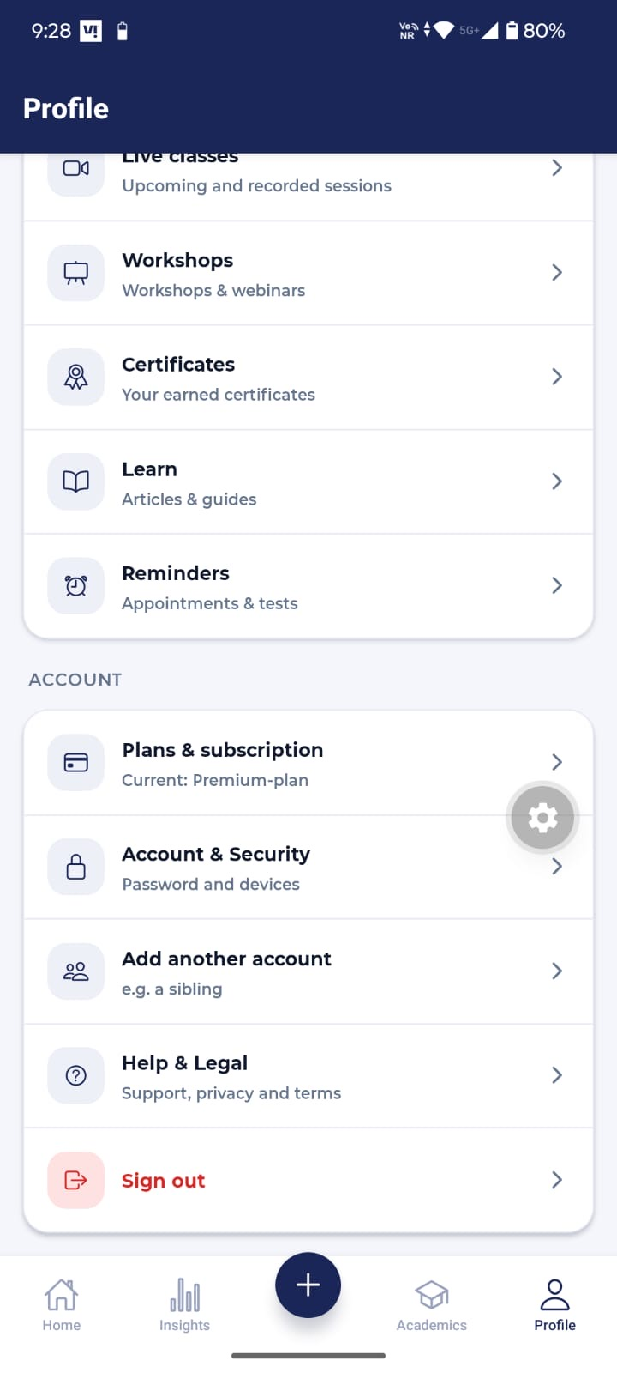 | Notes

Search Icon (Beside User1)
Screen 1 Search
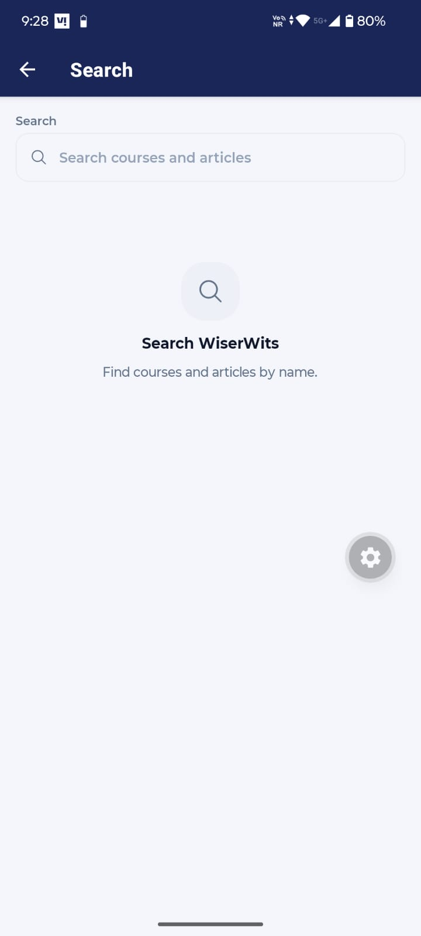 | Notes

Profile Section (All Tab Insides)

Screen 16 Account & Security
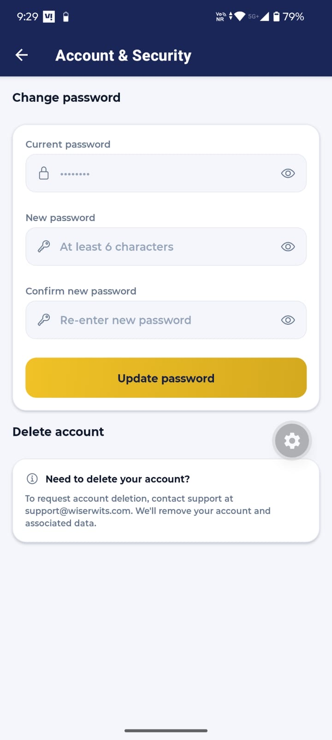 | Notes

Screen 17 Accounts
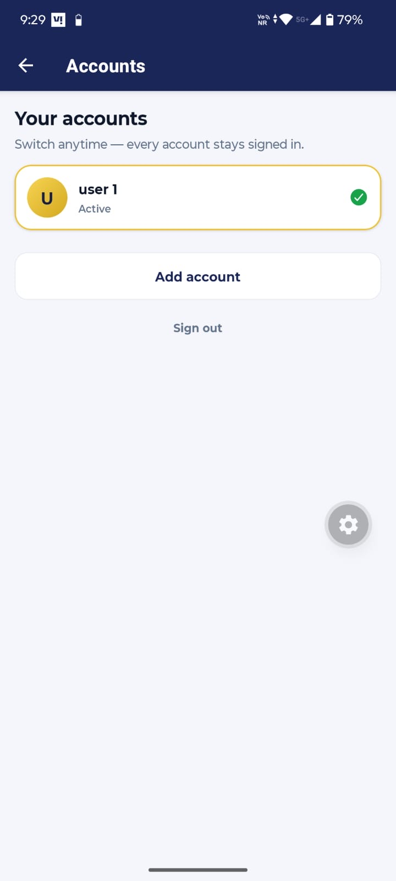 | Notes

Screen 18 Help & Legal – Support & Policies
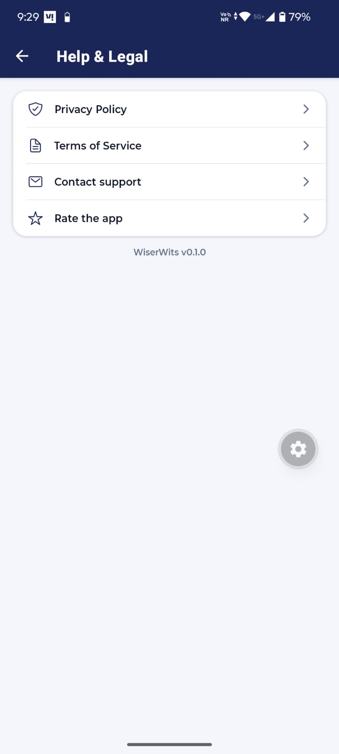 | Notes  60. Test these fields by uploading some documents, I’ll provide pdf for each section but for now you can test with random documents

